**GARAGE MANAGEMENT SYSTEM**

**College Name: KAAMADHENU ARTS AND SCIENCE COLLEGE,SATHY**

**College Code:bru4p**

**TEAM ID:NM2025TMID21150**

**TEAM MEMBERS:**

**Team LeaderName: MANIKANDAN R**

**Email:**manikandanr.cs23@kascsathy.ac.in

**Team Member1:MAKESH KUMAR D**

**Email:** makeshkumar.cs23@kascsathy.ac.in

**Team Member 2:KOWSHIKAA M**

**Email:** kowshikaa.cs23@kascsathy.ac.in

**Team Member 3:**KATHIRVEL K R

**Email: kathirvel.cs23@kascsathy.ac**

# 1.INTRODUCTION

## 1.1 Project Overview

## 

The Garage Management System is a valuable tool for automotive repair facilities, helping them deliver top-notch service, increase operational efficiency, and build lasting customer relationships. With its user-friendly interface and powerful features, GMS empowers garages to thrive in a competitive market while ensuring a seamless and satisfying experience for both customers and staff.

## 1.2 Purpose

The main objective of the project is to enable organizations to efficiently manage properties, tenants, and lease-related activities. It reduces manual intervention, improves accuracy, and ensures better compliance and communication.

# DEVELOPMENT PHASE

**Creating Developer Account:**

By using this URL[**-https://www.salesforce.com/form/developer-signup/?d=pb**](https://www.salesforce.com/form/developer-signup/?d=pb)

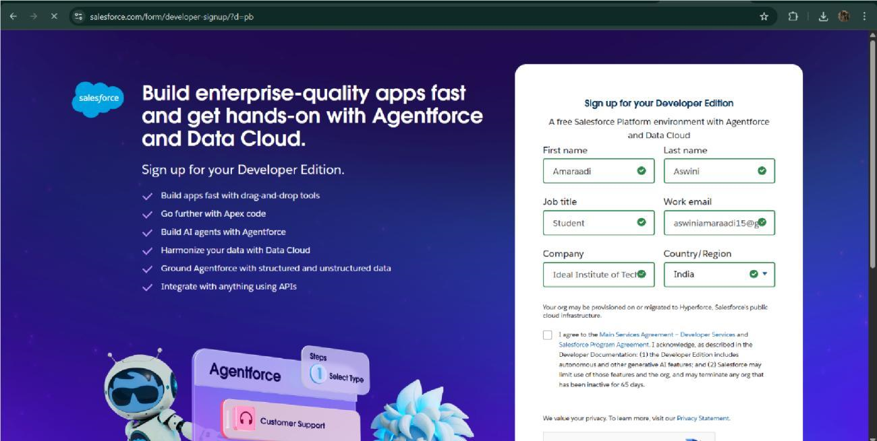

* Created objects: customer details,appointment,servicerecords,billing details and feedback.

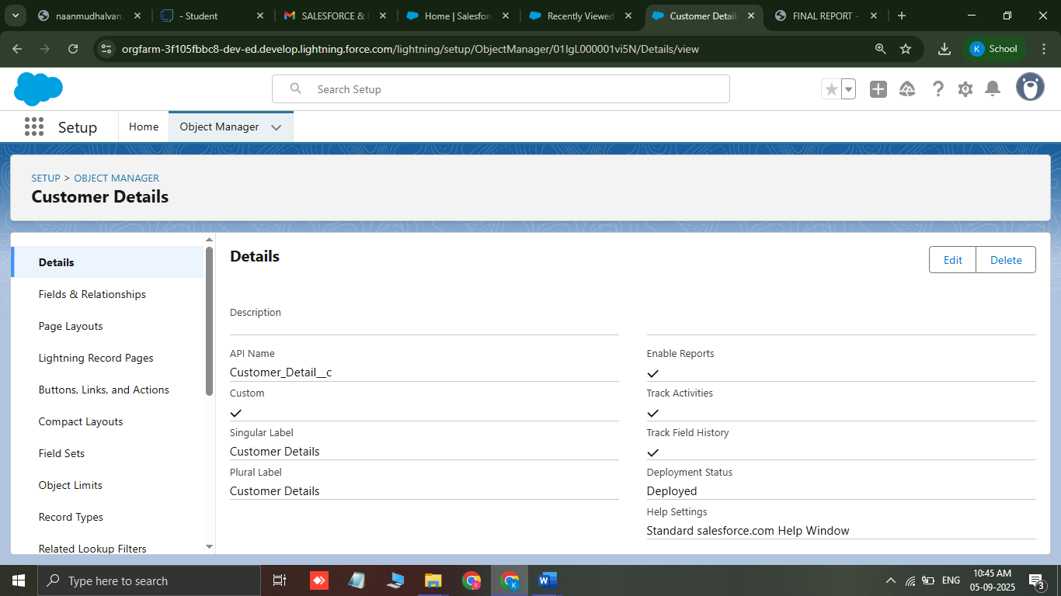

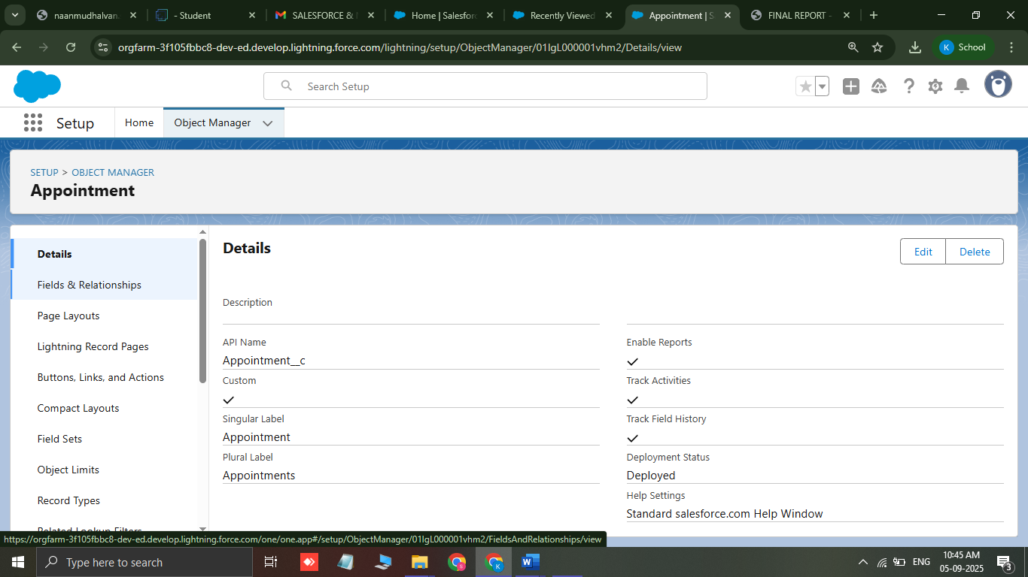

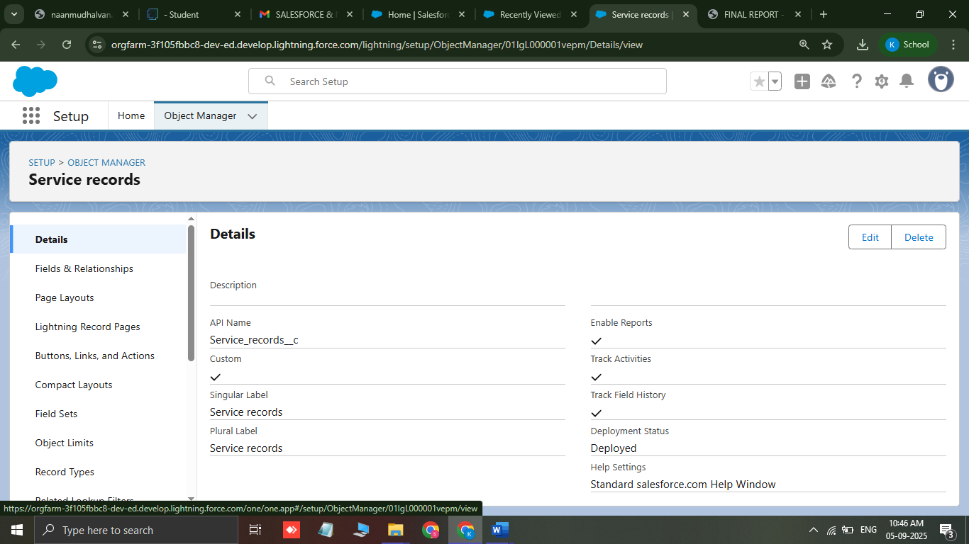

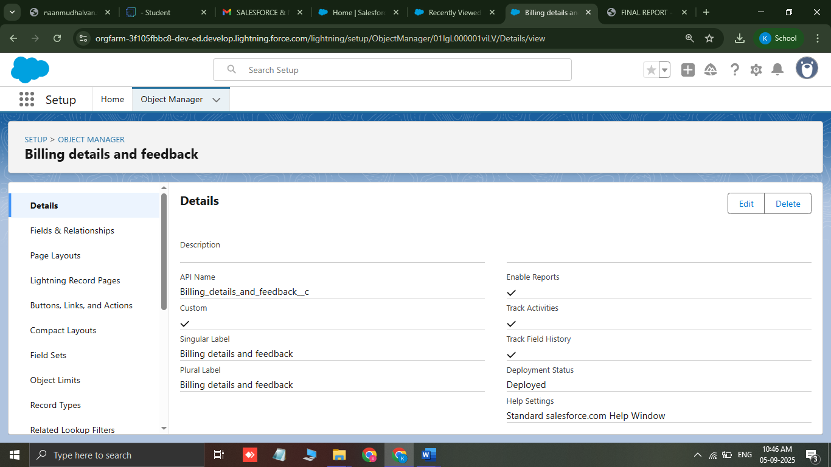

* Create a tabs : customer details,appointment,servicerecords,billing details and feedback.

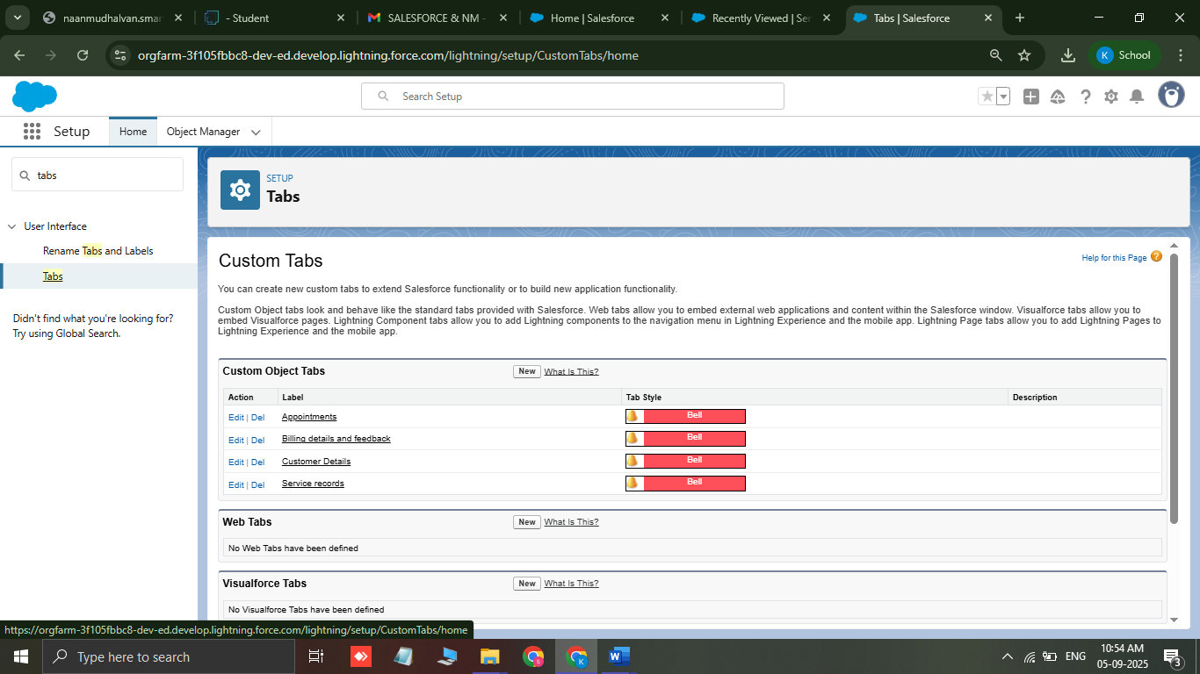

* **Create a Lightning App: Garage management system**

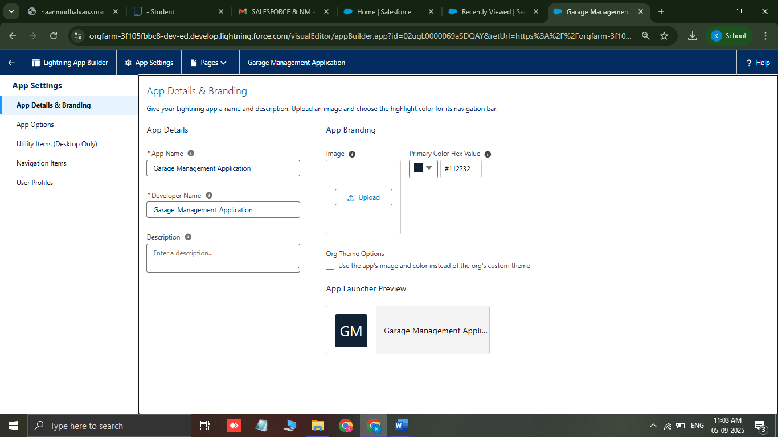

* **Creation of fields for the Customer Details object**

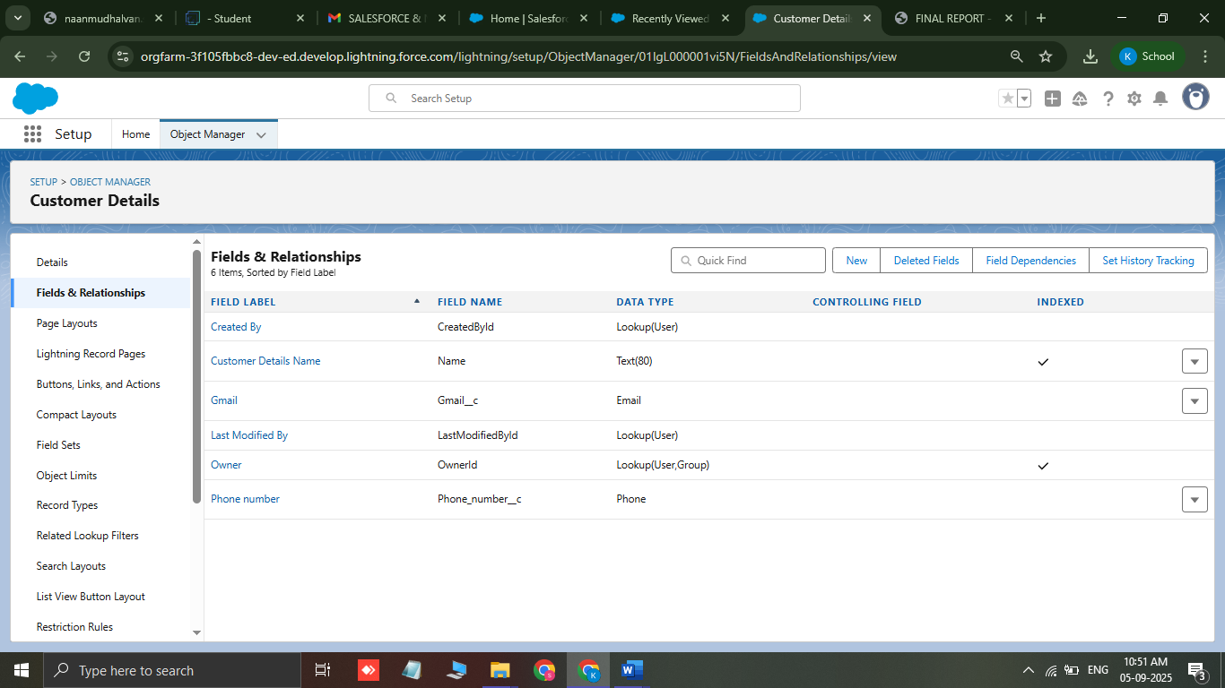

* **Creation of fields for the Appointment object**

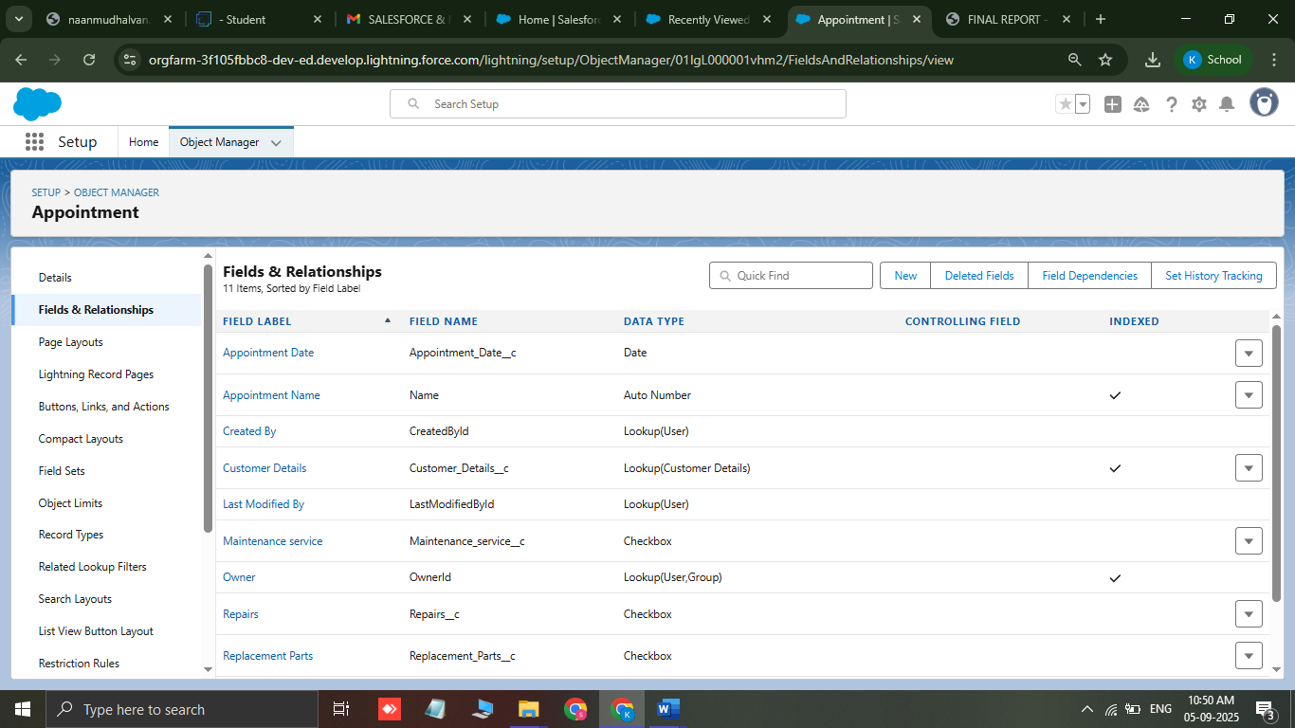

* **Creation of fields for the Service records object**

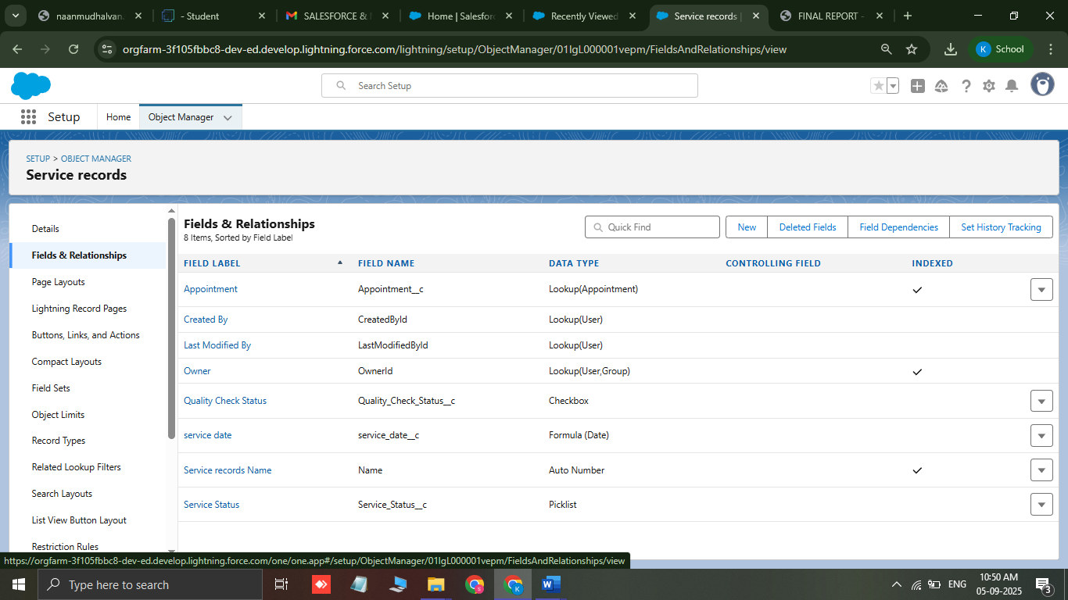

* **Creation of fields for the billing details and feedback object**

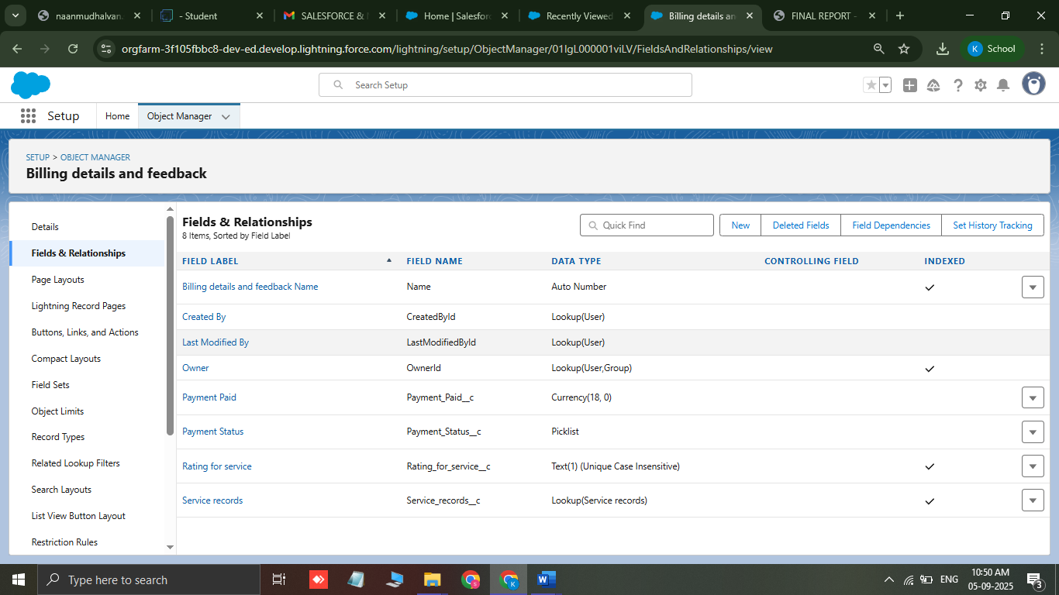

* **create a validation rule to an Appointment Object**

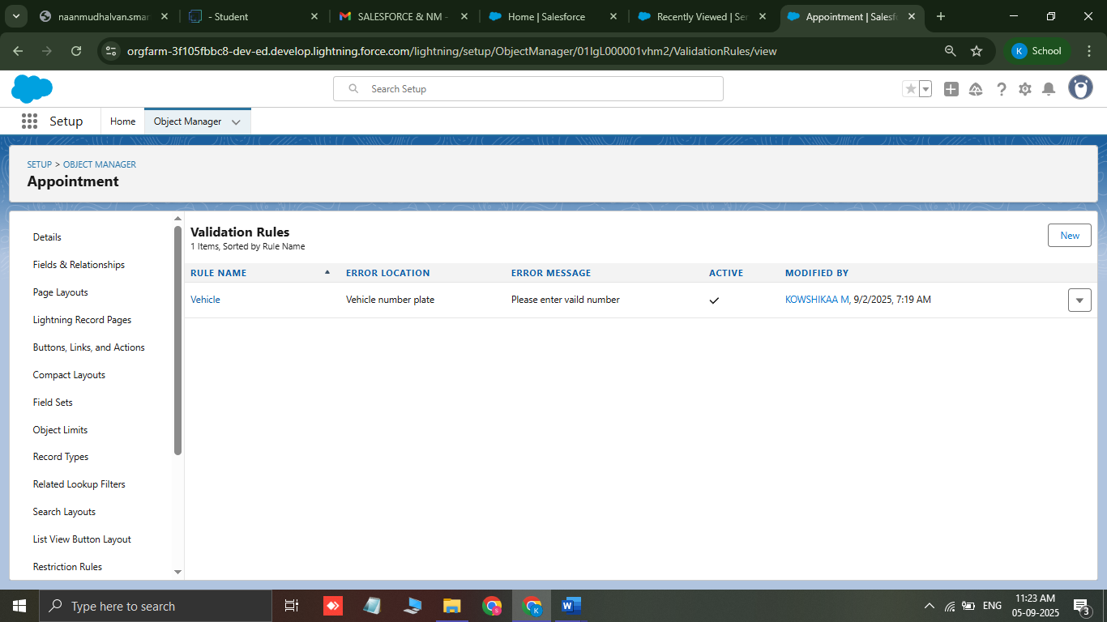

* **create a validation rule to an Billing details and feedback Object**

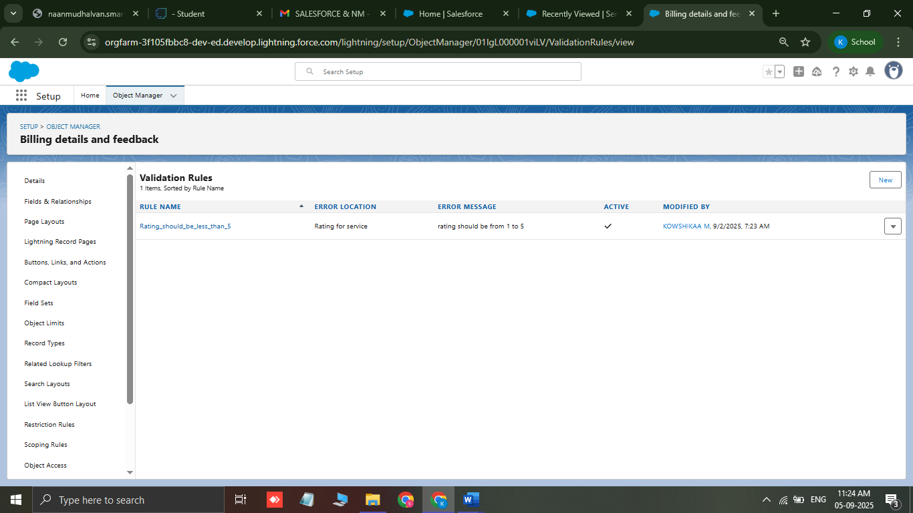

* **create a matching rule to an Customer details Object**

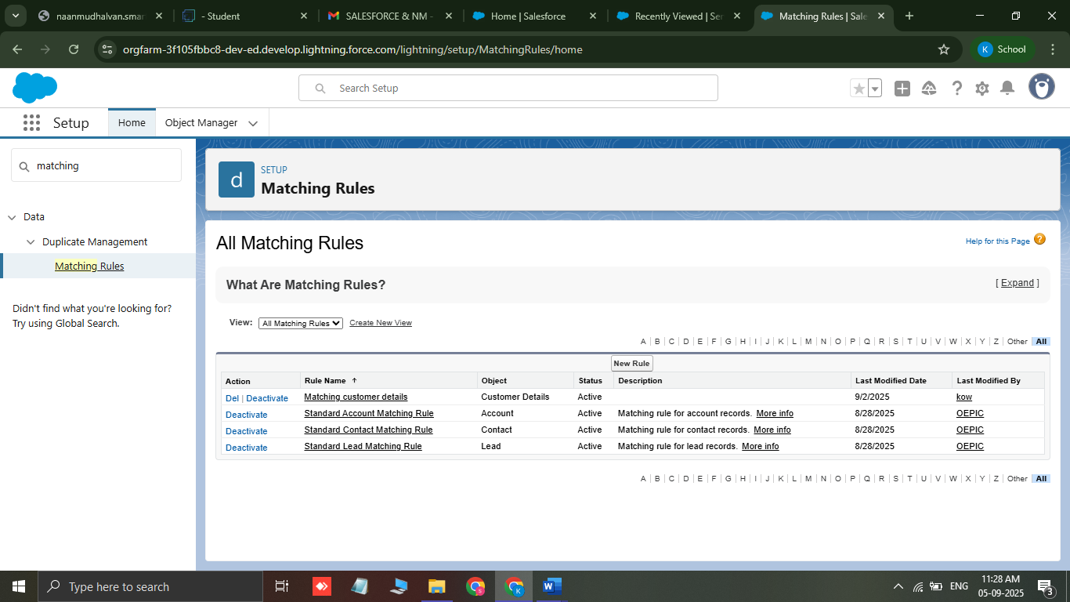

* **create a Duplicate rule to an Customer details Object**

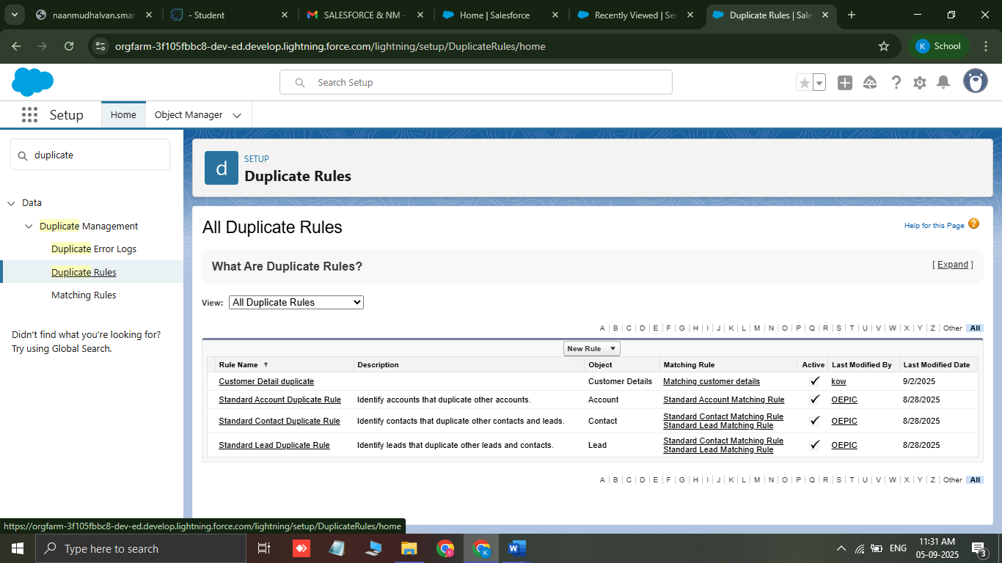

* To create a manager profile

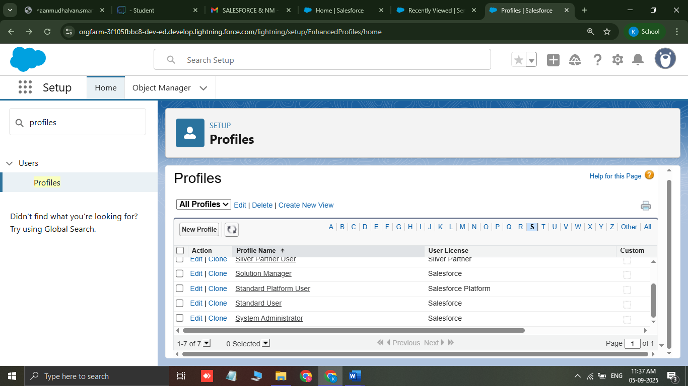

* To create a **sales person Profile**

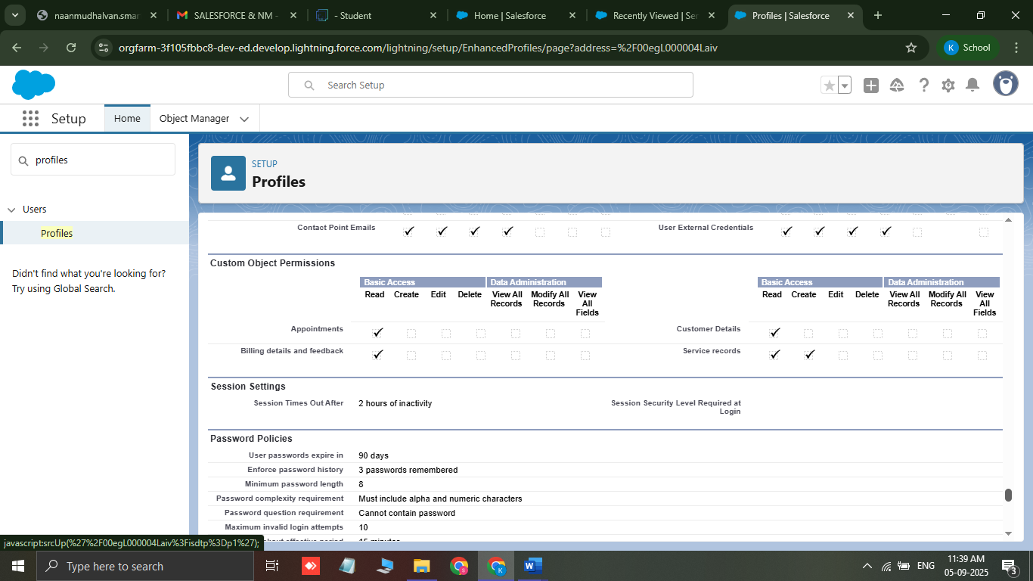

* **Creating Manager Role**

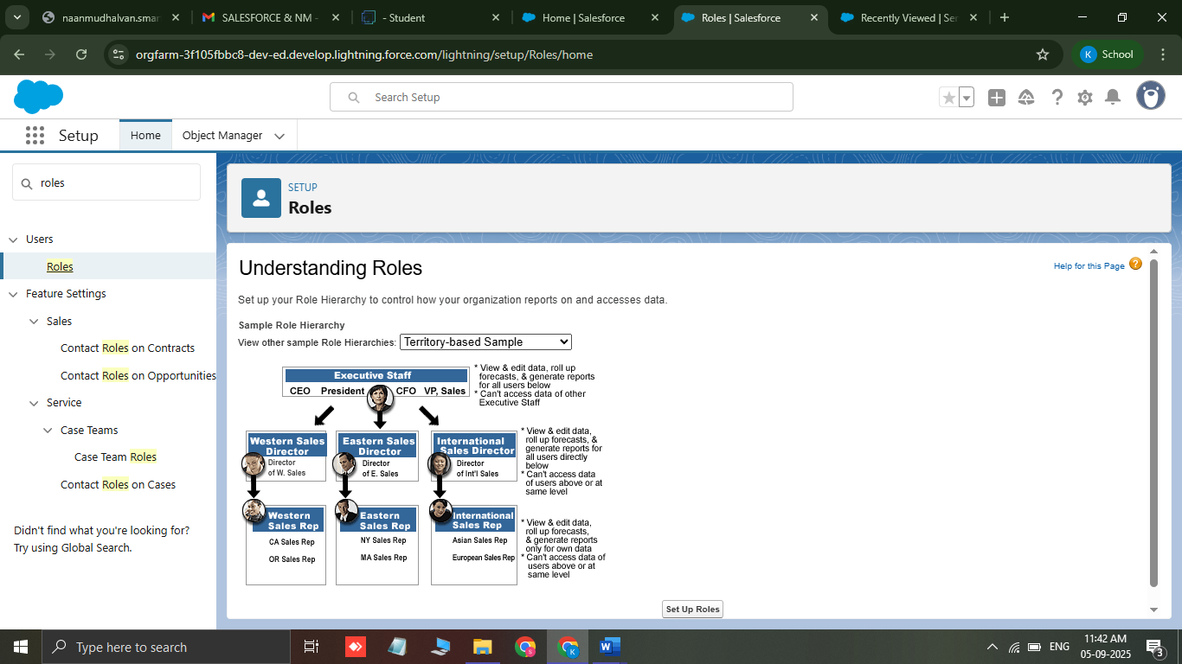

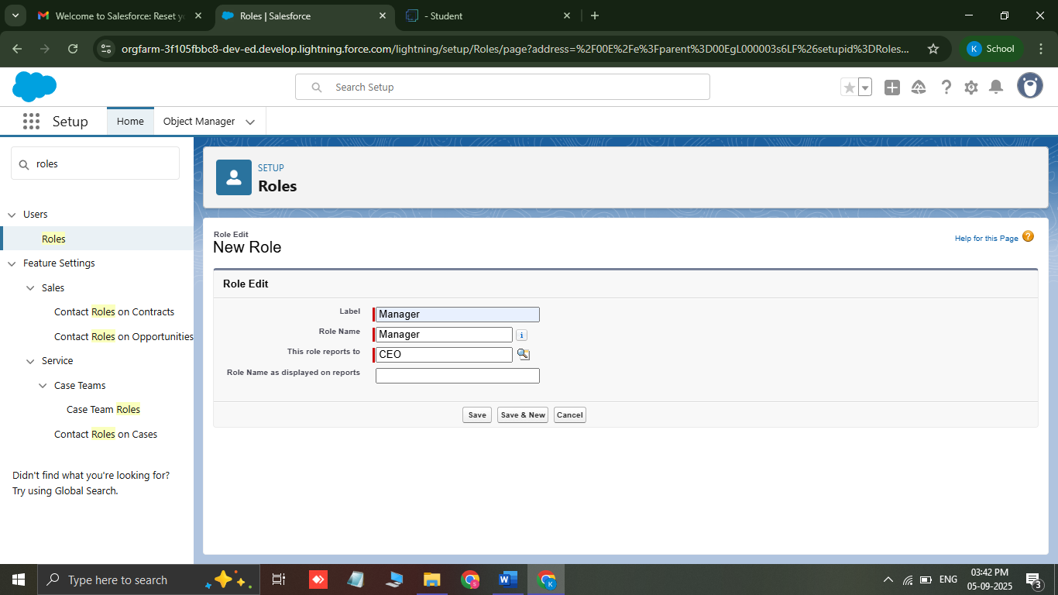

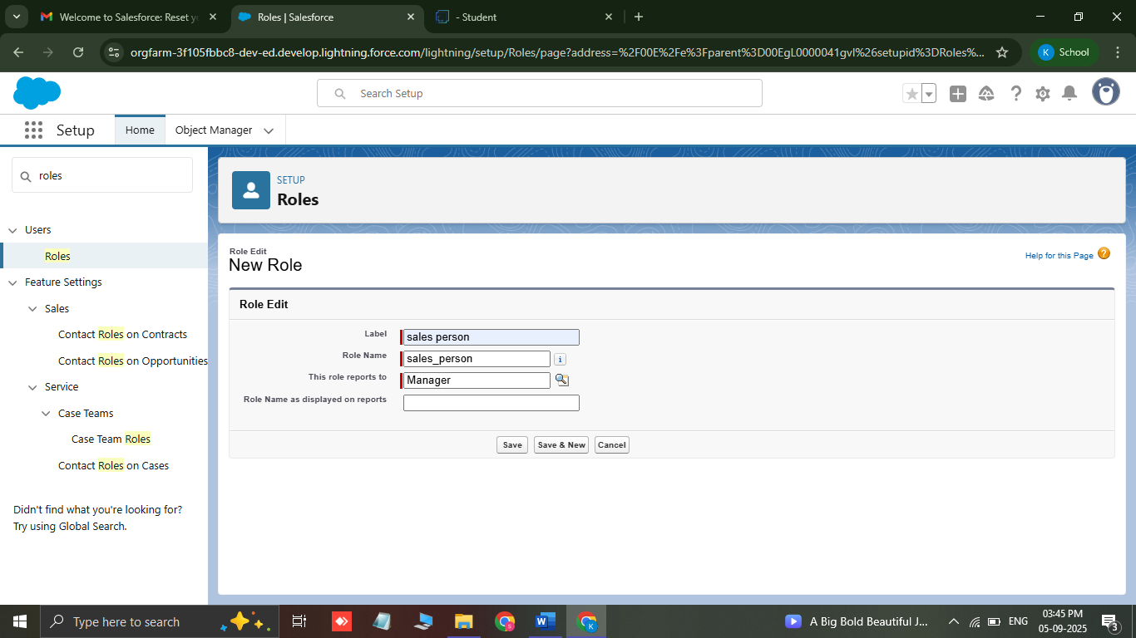

* **Create User**

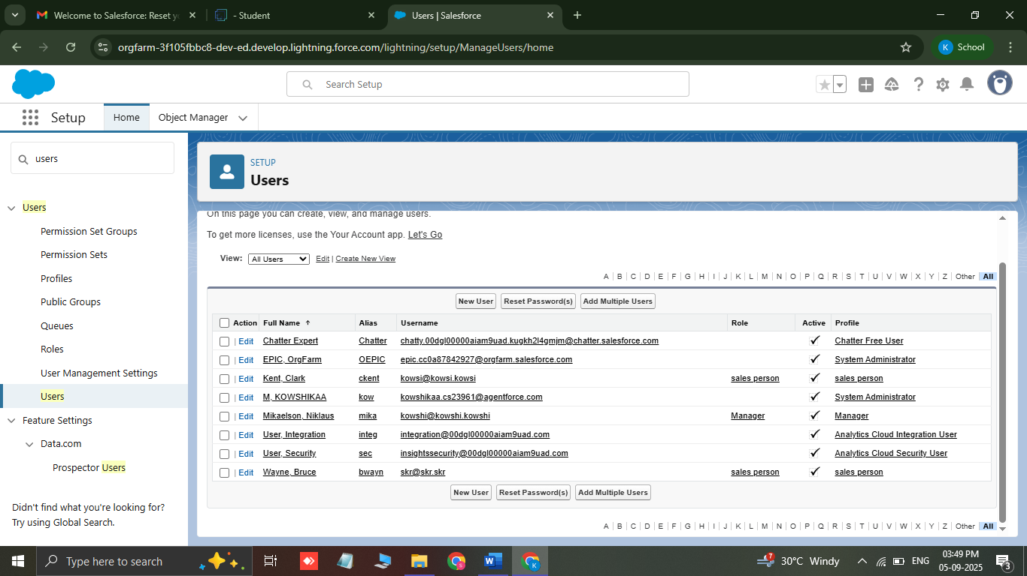

* **Creating New Public Group**

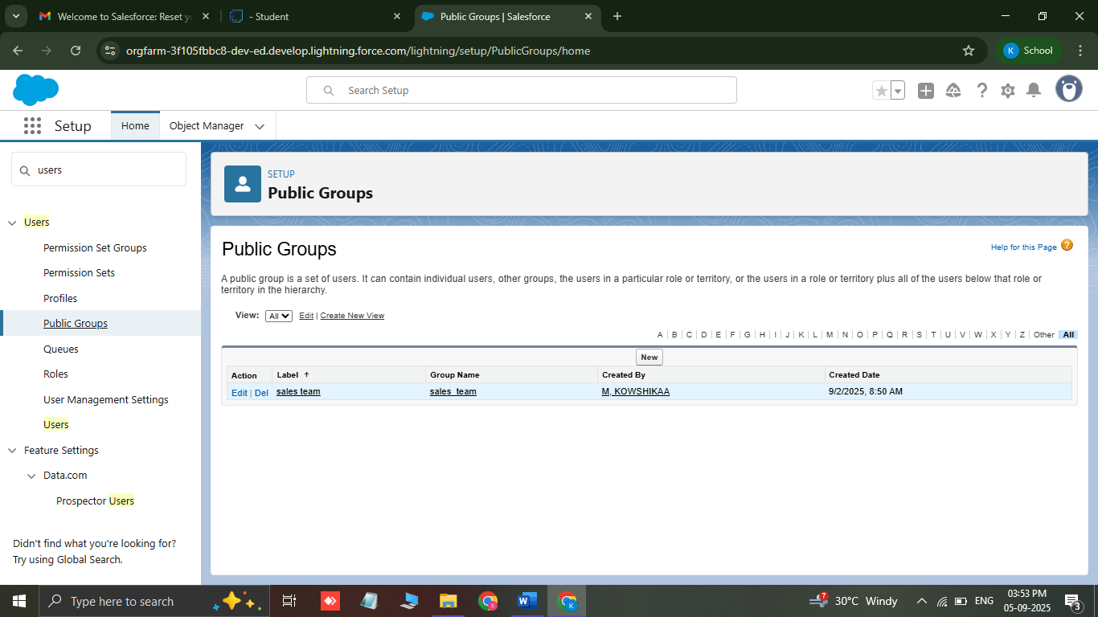

* **Sharing setting**

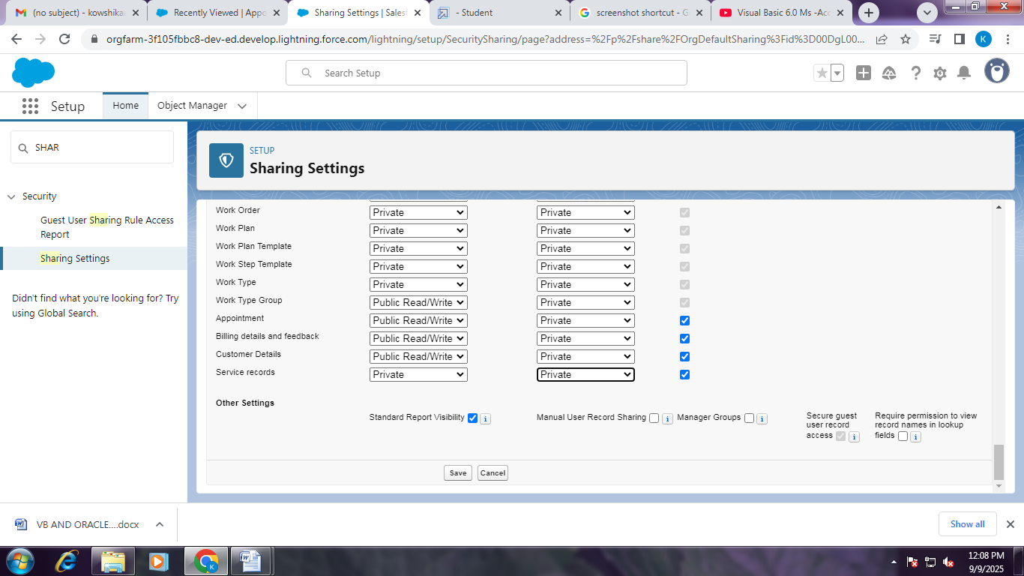

* **Flow**

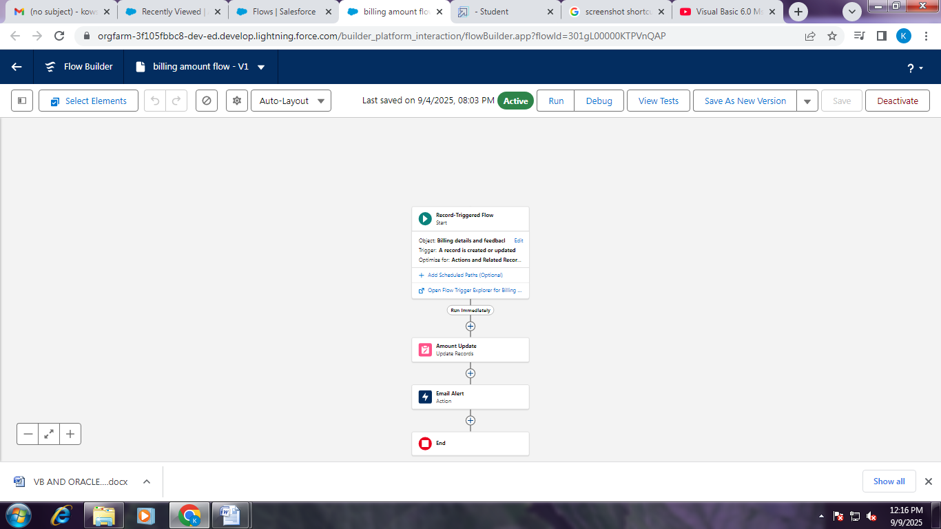

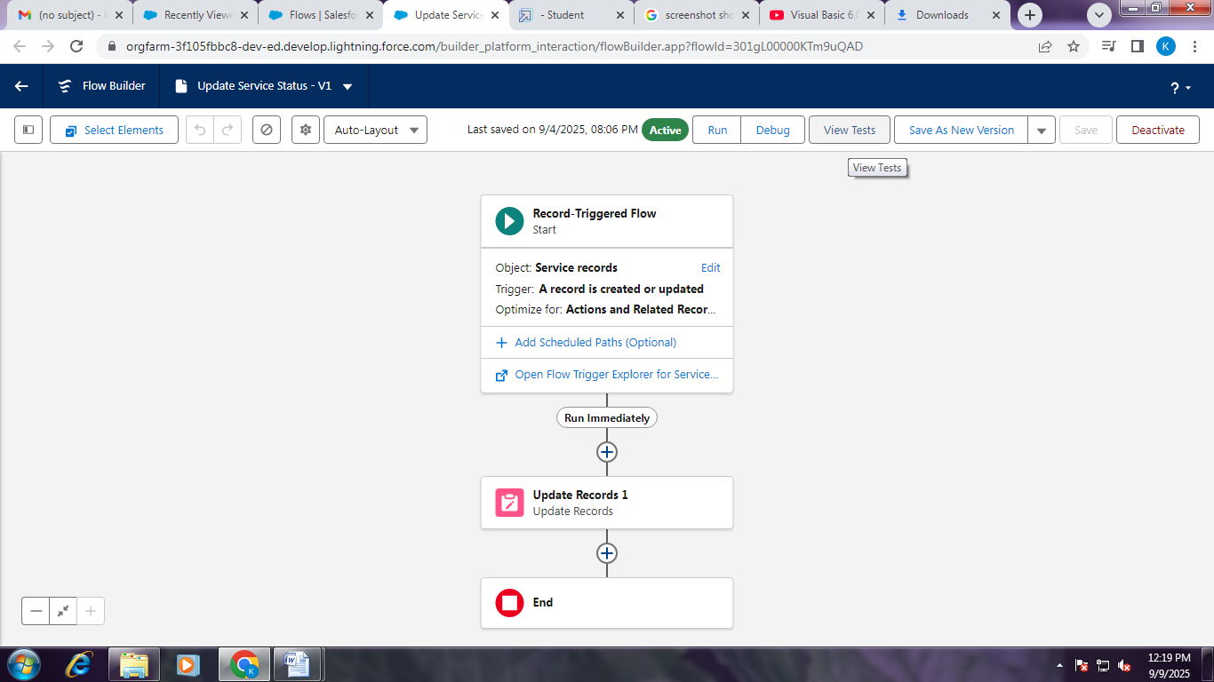

* **Apex trigger**

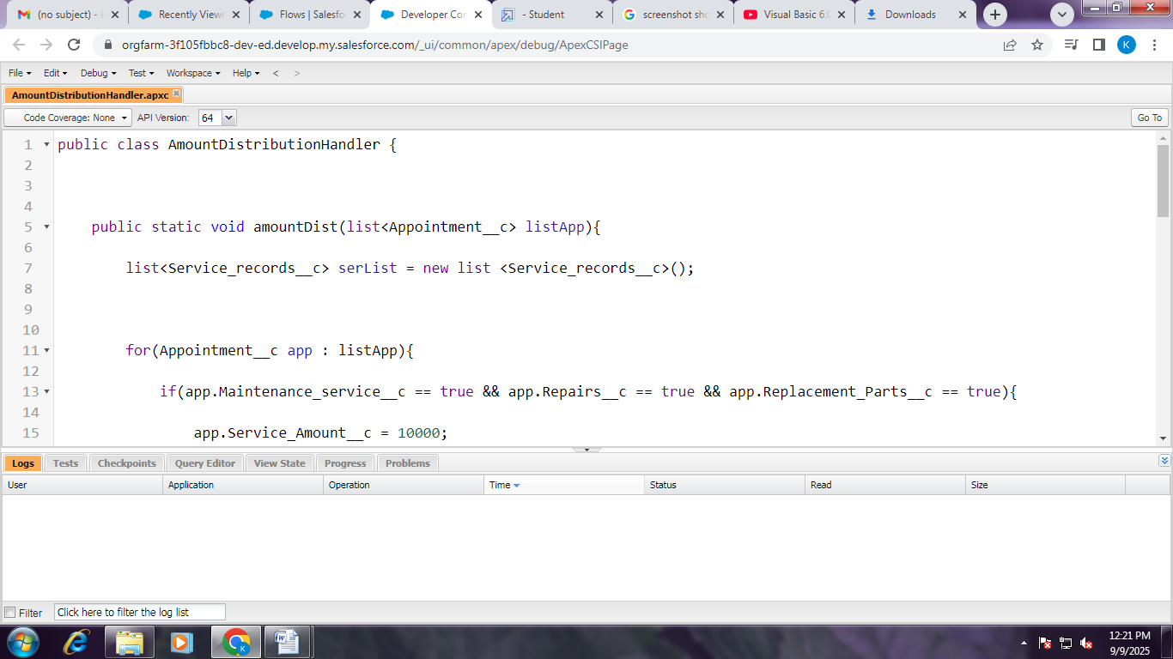

* Reports

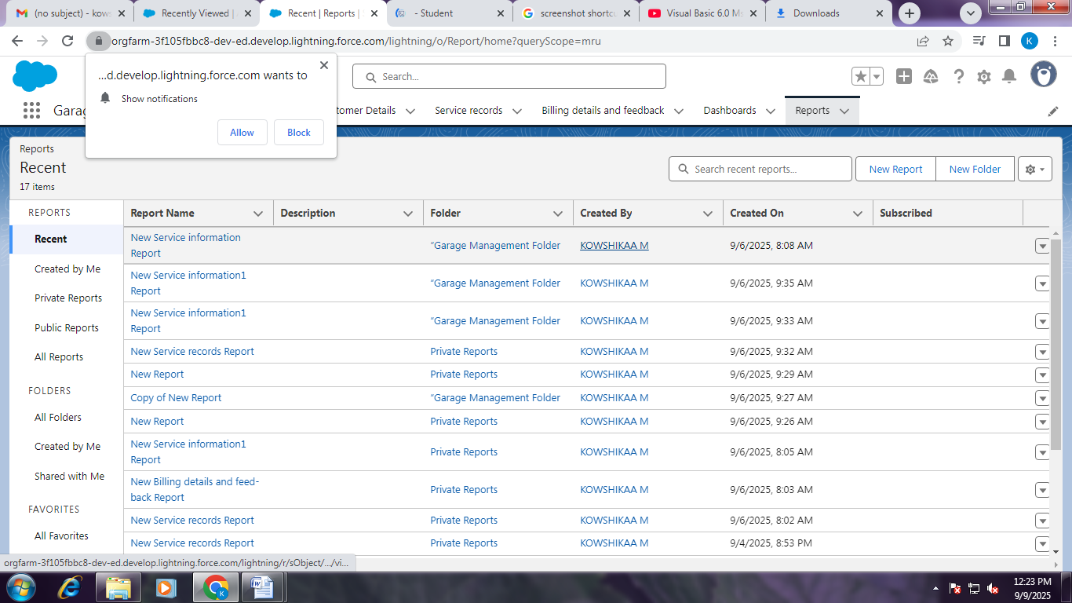

* Dashboard creation

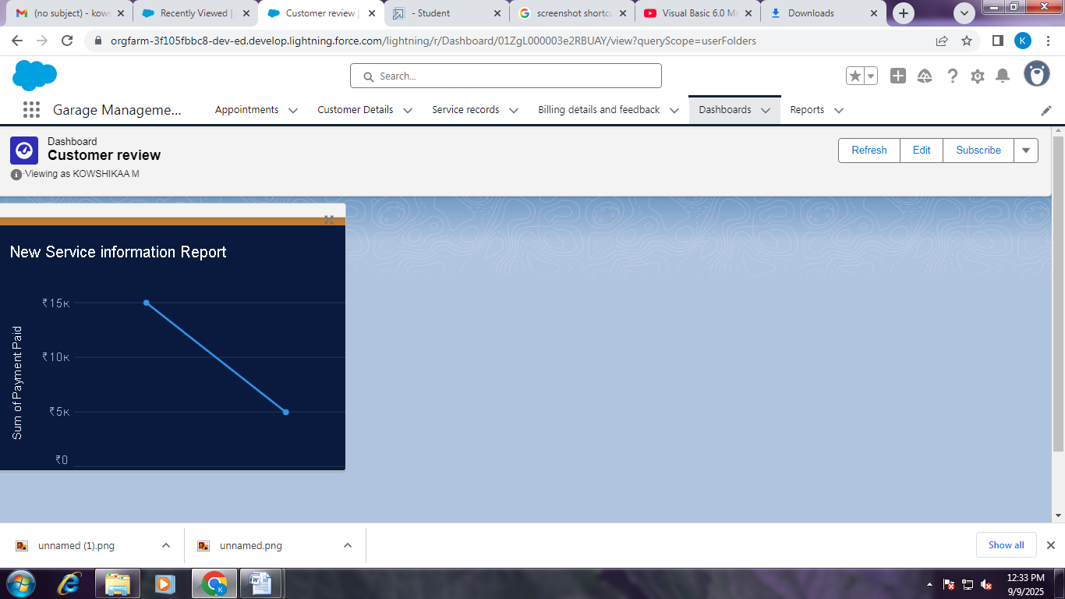

* User Adoption

